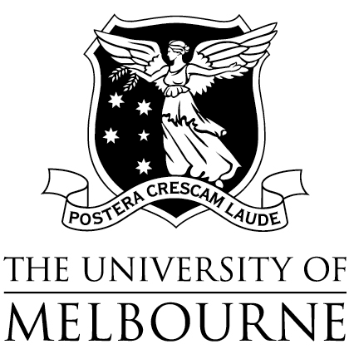
School of Health Sciences

REFEREe Report

Who should complete this form?
This form should be completed by an individual familiar with the applicant’s professional experience. You may type your responses in the boxes provided. Your comments will be treated as strictly confidential.

Send your completed form to:
MDHS Graduate Coursework Admissions T: 13MELB (13 63 52)
Level 1, Brownless Biomedical Library E. mdhs-gradcw-admissions@unimelb.edu.au
University of Melbourne
Victoria, 3010

APPLICANT INFORMATION

Applicant Name
Course

PROFESSIONAL EXPERIENCE

Please indicate the capacity in which you have known the applicant and the duration:

Please comment on the applicant’s personality, creativity, initiative, community awareness and participation:

Please comment on the applicant’s sensitivity towards diverse persons in difficult circumstances and the applicant’s ability to deal with these situations objectively:

Please comment on the applicant’s clarity of thinking and communication, and organisational abilities:

Please comment on the applicant’s personal and social responsibility and potential for ethical professional practice:

Please comment on the applicant’s strengths and weaknesses:

Please comment on the overall quality of the applicant’s interpersonal relationships:

Other comments:

Would you recommend this applicant for selection?
Yes No

REFEREE DETAILS

Name
Signature
Date
Position
Institution
Telephone

